Android alert dialog example

By [mkyong](http://www.mkyong.com/author/mkyong/" \o "mkyong) | March 8, 2012 | Updated : August 29, 2012 | Viewed : 517,147 times

In this tutorial, we show you how to display an alert box in Android. See flowing Steps :

1. First, use the AlertDialog.Builder to create the alert box interface, like title, message to display, buttons, and button onclick function
2. Later attach above builder to AlertDialog and display it.
3. Done.

*P.S This project is developed in Eclipse 3.7, and tested with Android 2.3.3.*

1 Android Layout Files

Simpel layout file, display a button on screen.

File : res/layout/main.xml

Markup

<?xml version="1.0" encoding="utf-8"?>

<LinearLayout xmlns:android="http://schemas.android.com/apk/res/android"

android:layout_width="fill_parent"

android:layout_height="fill_parent"

android:orientation="vertical" >

<Button

android:id="@+id/buttonAlert"

android:layout_width="wrap_content"

android:layout_height="wrap_content"

android:text="Show Alert Box" />

</LinearLayout>

2. Activity

When user click on this button, display the alert box, with your pre-defined alert dialog interface.

*File : MainActivity.java*

Java

package com.mkyong.android;

import android.app.Activity;

import android.app.AlertDialog;

import android.content.Context;

import android.content.DialogInterface;

import android.os.Bundle;

import android.view.View;

import android.view.View.OnClickListener;

import android.widget.Button;

public class MainActivity extends Activity {

final Context context = this;

private Button button;

public void onCreate(Bundle savedInstanceState) {

super.onCreate(savedInstanceState);

setContentView(R.layout.main);

button = (Button) findViewById(R.id.buttonAlert);

// add button listener

button.setOnClickListener(new OnClickListener() {

@Override

public void onClick(View arg0) {

AlertDialog.Builder alertDialogBuilder = new AlertDialog.Builder(

context);

// set title

alertDialogBuilder.setTitle("Your Title");

// set dialog message

alertDialogBuilder

.setMessage("Click yes to exit!")

.setCancelable(false)

.setPositiveButton("Yes",new DialogInterface.OnClickListener() {

public void onClick(DialogInterface dialog,int id) {

// if this button is clicked, close

// current activity

MainActivity.this.finish();

}

})

.setNegativeButton("No",new DialogInterface.OnClickListener() {

public void onClick(DialogInterface dialog,int id) {

// if this button is clicked, just close

// the dialog box and do nothing

dialog.cancel();

}

});

// create alert dialog

AlertDialog alertDialog = alertDialogBuilder.create();

// show it

alertDialog.show();

}

});

}

}

3. Demo

Start it, display a button.

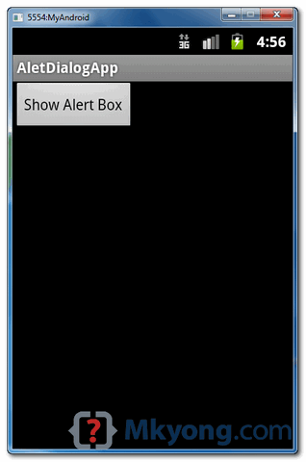

When button is clicked, display the alert box

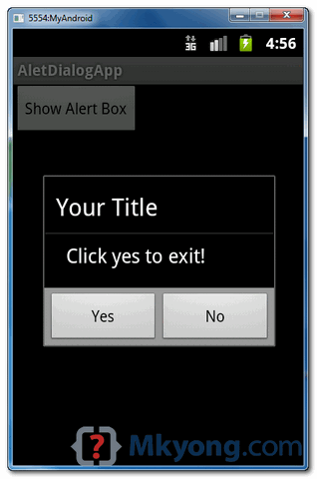

If “Yes” button is clicked, close the activity and return back to your Android main screen.

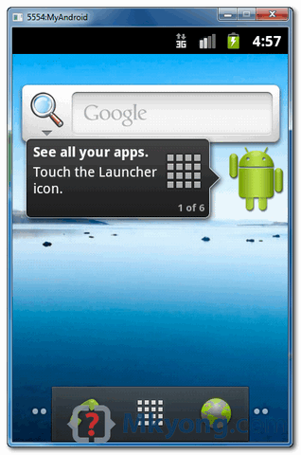

Download Source Code

Download it – [Android-Alert-Dialogl-Example.zip](http://www.mkyong.com/wp-content/uploads/2012/03/Android-Alert-Dialogl-Example.zip) (16 KB)